Version 31.10.2008 Robin
- changes…

Version 6.11.2008 Johan
Added lines in matlab code to re-scale the frequency regressors. Page.. ~ 16

DAY OF THE SCAN

Before the scan
Take laptop and prepare EMG stuff
Test EMG/batteries
Check fMRI room (beamer, mirror, scherm)
Take fMRI-glasses

Scanning
Attach the EMG wires, check the signal. Replace when the signal is not good enough.

%After scanning, copy original data to the net:

Create a new folder for the patient 6666 in x/onderzoek/fMRI/Tremor/ruw/6666
Create new folders and files
Ruw/6666/parrec
Ruw/6666/trc
Ruw/6666/channels.txt
Ruw/6666/files.txt
Ruw/6666/notes.txt
% Example files for channels.txt, notes.txt and files.txt are in x/onderzoek/fMRI/Tremor/ruw .

→ channels.txt
→ notes.txt
→ files.txt

From MRI computer: copy parrec files in 6666/parrec
From EMG computer: . copy trc files in 6666/trc

CONVERSION OF ROW FILES

TRANSFORMATION OF PARREC FILES

% This is the Cygwin routine to transform parrec files in 4D.img and 4D.hdr files. This routine also creates new folders in X:\Onderzoek\fMRI\Tremor\pp\6666 with the name of the sequences (i.e. pp\6666\tremor1\fmri, pp\6666\tremor2\fmri and pp\6666\t1)

In Cygwin type:

$ cd /cygdrive/x/Onderzoek/fMRI/Tremor/ruw/

$ /cygdrive/x/ICT/Software/mltoolboxes/emgfmri/conversion/fmri/prep.sh Tremor 6
666

EMG

TRANSFORMATION OF .TRC FILES (EMG)

%this you do in Matlab:
%go to the patient folder X:\Onderzoek\fMRI\Tremor\ruw\6666\trc
>> batch_emg_to_mat('Tremor','6206')

%this will convert .trc files to emg.mat files in all the folders and create 2 extra files inside the EMG folder (only if emg outside the scanner was done):
- emg_nofield.mat: this is emg outside the scanner, while practicing the task (i.e. tremor1 will go in the folder tremor1/emg)
- and emg_prescan.mat : this is emg inside the scanner, scanner not running
This takes approximately 30 min (even more).

N.B. It is likely that at one point you get an error message saying “no marker triggers to import on MRK channel”. Yu can ignore this and click OK

LOG files

TRANSFORMATION OF .log FILES

>> batch_log_to_mat(‘Tremor’, ‘6666’)

%if you have .log files this will convert them to block.mat and event.mat. If don’t have log files, you still need to run this to create the model block.mat in x:\Onderzoek\fMRI\Tremor\pp\6666\tremor1\regressor\block.mat

PREPROCESSING
Preprocessing Fmri

SPM5 PREPROCESSING

%general information:
- N. of volumes is 240 for tremor 1 and 160 for tremor 2
- n. of slices is 50
- TR is 2.888889
- TA (time at which the last slide starts) is 2.888889– (2.9/50) = 2.83
- Slice order is [1:2:49 2:2:50] (%this is interleaved: go from 1 to 49 in steps of 2. At the moment it is [1:2:49 2:2:50] . Soon it could become [1:7:43] [2:7:44] [4:7:45] [4:7:46] [5:7:47] [ 6:7:48] [7:7:49])
- Reference slide is 1`.

Start Matlab
make sure to be in x:/Onderzoek/fMRI
Press emgfmri button (this will add the path to the softwares which are in X:\ICT\Software\mltoolboxes\emgfmri
X:\ICT\Software\mltoolboxes\spm5
X:\ICT\Software\mltoolboxes\eeglab5.03)

%NB to make the button if it is not there:

>> type x:/Onderzoek/fMRI/knop.m

base=regexprep(pwd,'(^.*)(Onderzoek.*)','$1');

% my own emg-fmri toolbox
disp(['adding emg-fmri toolbox to the path, base = ' base])
addpath(genpath([base '/ICT/Software/mltoolboxes/emgfmri']));

% spm5, nifti and eeglab
disp(['adding eeglab, spm5 and nifti'])
addpath([base '/ICT/Software/mltoolboxes/spm5'])
addpath([base '/ICT/Software/mltoolboxes/eeglab5.03'])
addpath([base '/ICT/Software/mltoolboxes/nifti_20070503'])

Drag this to the bar and give a name.

>> spm fmri

>> batch_fmri_preprocessing(‘Tremor’,’6666’,’tremor1’,’tremor2’)

%this command will do all that follows

SLICE TIMING CORRECTION

Go to the directory where you want to work
(i.e. x:\Onderzoek\fMRI\Tremor\pp\6666\tremor1)
→ Display
Select the 4D.img
→ done

REORIENT IMAGE
Indicate the AC with the cross lines
→ reorient images
Select all files (1:1000000, right click select all)
→ done

SLICE TIMING
→ slice timing
Slice timing
Data
New session
specify files
select all the files from the correct directory

Put in all the parameters:
Number of slices 50
TR is 2.8889
TA is 2.8311
Slice order [1:2:49 2:2:50]
Reference slide is 1
→ Run
% from slice timing you will get files beginning with a (a4D)

REALIGNMENT
→ realign
→ realign: Estimate & reslice
→ data
→ new session
→ session
→ specify files:
Select all the a4D files by typing: a4D* 1:100000
→ estimation options
→ Num Passes : register to first
→ interpolation : 4th degree B-Spline
→ reslice options
→ resliced images: all images +mean image
→ interpolation: 7nd degree B-spline
→ Run

%you get now a diagram of the 6 possible directions in space. It is acceptable if displacement is <

%After realignment you get files with the name “rp_a4D.txt”and one “meana4D.nii”

COREGISTRATION
Check Orientation

→ display: T1
Change parameters (roll = 1.57; yaw = -1.57)
Put the crosshair on AC by changing the parameters
→ reorient images – select T1 (and all the functional scans, separately?)

→ chek reg (%to check orientation)
Select all the scans you want to compare (they will appear in the same window) and check

→ estimate
→ model estimation
→ method

→ coregistration
→new coreg estimate
→reference image = meana4D.nii
→source image = T1
→ estimation otptions
→ objective function = entropy correlation coefficient

→ RUN

%it is possible to coregister the other sessions to the first one, if you have already resliced and realigned them all:
- instead of using “source image” = T1, “source image”= meana4D.nii in the other session (i.e tremor2)

NORMALIZE

%if you want to normalize to an “average brain” for group analysis

→ normalize
(source image = T1
Reference inmage= average brain
Images to write=all the a4D files
%after this you get wa4d.nii)

SMOOTHING
→ smooth
→ images to smooth = all the a4D and meana4d (and wa4D if present)

%you wil get files with an s in fromt (sa4D.img and sa4D.hdr or swa4D.img))

%NB This will genereate normalized AND non-normailzed imags. In the end we will have he following files:
- swa (smoothed, warped images) → if you need to match them to standard t1
- sra (smoothed, non-warped images) → if you need to match them to the subject’s own t1
- all the others coming form the preprocessing (see above)

%Now pre-processing of fMRI is done

Here we will insert the text of the file “guide_emg_preprocessing” by Johan
This will guide you through from the emg.mat file we have just created to emg_4.mat (which is the artefact-free emg)

ANALYSIS
%If the model does not exist for some reason, you should create the block design in SPM (check some other maual)

Block design
%After fMRI pre-processing is done (see above), for tremor 1 and tremor2 the model of the block design has already been created and is in x:\Onderzoek\fMRI\Tremor\pp\6666\tremor1\regressor\block.mat

Movement parameters
% Before you decide to use the movement parameters, they have to be checked. You have to check if they are high or low and block-like or not.

>> load rp_a4D.txt

>> figure;subplot(2,1,1);plot(rp_a4D(:,1:3));subplot(2,1,2);plot(rp_a4D(:,4:6))

% If the parameters are low and block-like, you can try to do the model without the movement parameters.
If the parameters are high and block like there is a problem.

Model making
Model of the block design
>> spm fmri
Create …\pp\6666\tremor1\results folder
Create …\pp\6666\tremor1\results\ folder with the name of the model (i.e. block without rest)

→ specify first level
→fMRi model specification
→ directory
Specify files: …\pp\6666\tremor1\results\block without rest
→ timing parameters
→units for design = seconds
→ interscan interval = 2.8889
→microtime resolution = 16
→microtime onset = 1 (%this depends on the “slice timing”; for us it was set at 1 because we have interleaved)

→data and design
→new subject\session
→scans
→specify files (%which files you want to analyse) = .\pp\6666\tremor1\fmri\swa4D (if you want it wrapped)
or
.\pp\6666\tremor1\fmri\sra4D (if you want it not-wrapped)

%To see more than 1 file, the scale has to be changed to 1:1000

→ multiple conditions
→specify file = x:\Onderzoek\fMRI\Tremor\pp\6666\tremor1\regressor\block.mat
%if you want ot add the movement parameters (rp_a4D file):
→ multiple regressors
→ specify file = x:\Onderzoek\fMRI\Tremor\pp\6666\tremor1\regressor\ rp_a4D.txt

→ save as Job.mat (in the pp\6666\tremor1\results\block without rest)
%this job includes all the options you have used up to now

→ run

%you will get the SPM.mat file (which includes the matrix, the scans, etc…).
%It is good to check it at this point. This you do in SPM by
→ Review
→ select spm.mat
→ click Design
→ design matrix

% That will look like this
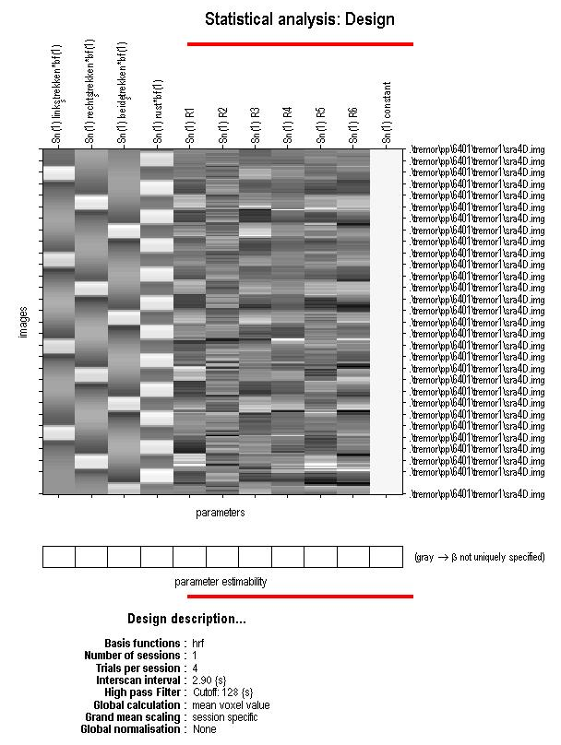
%In this example the first 4 columns are the block design (postureL, postureR, posture Both, rest) and the next 6 columns are the movement parameters.

%you can also check design othogonality
→ Design orthogonality
%this will look like this
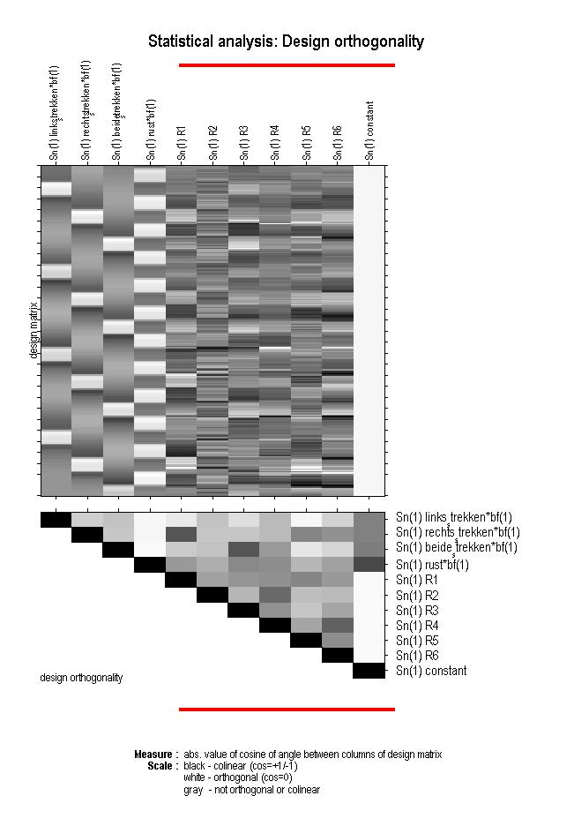

%darker bocks at the crossing between 2 conditions mean high interdependence

%now we want to estimate the model
→estimate
→model estimation
→specify files = x:\Onderzoek\fMRI\Tremor\pp\6666\tremor1\block without rest\SPM.mat
→method = classical
→run

%it will give values to the voxels, according to the matrix that has been defined. You will get the results. This will take a lot of time.

CONTRASTS

%To look at the activation of the brain at different conditions, use contrasts
In SPM:
→ Results
→Select SPM.mat in the directory
x:\Onderzoek\fMRI\Tremor\pp\6666\tremor1\block without rest\SPM.mat
→Define the contrasts you are interested in
% you’d better define the contrasts you want to do in advance, make a list and then do them always in the same order in all the different subjects. Contrast can be like 0100.
→Mask with other contrasts = ‘NO’
→Name your contrast
→none
→threshold = 0.001
→extend threshold = 0
→Overlays
→sections= select the t1 (%the scan is in the folder fMRI. This is when you want to use the T1 of the subject, otherwise you have to upload the average t1)
→ Goto global Maxima
%you can also use different p values, if appropriate.
Your results will look like this

Figure here

%It is good to save your results in a separate folder in .fig and.jpg files

Cheched until here
Model of the block + emg design

(Small) guide to scripts for EMG model extraction

This guide is about using the EMG to make you a model for use in fMRI analysis. Basically the EMG gives to opportunity to add another modality of monitoring to your fMRI experiment, and in the case of movement disorders this is an addition, for EMG activity gives you a better idea of the muscle's activity than watching movements on a video. (aside: both modalities are needed however and in the future, it would be ideal if all our experiments have on-site video monitoring and time-locked with the EMG) To actually do the coupling with EMG and fMRI (extract a model from the EMG) we use matlab, a program that gives the opportunity to analyze EMG traces with the EEGLAB toolbox, and also analyze fMRI data with the SPM5 toolbox. I will demonstrate this process for one patient case in the Tremor study.

The scripts are located on the KNF server and are basically a toolbox in itself to facilitate the entire EMG-fMRI analysis in whatever form. For example, in the Loops study, we try to make a model from the myoclonic jerks and the phasic modulation of dystonic muscle tension, and correlate both to the BOLD signal. In Tremor, we try to extract the tremor from the EMG by frequency analysis and correlate it to the BOLD signal. This correlation (or model-extraction) is itself a sub-process of the entire EMG-fMRI workflow which will be discussed elsewhere. The emg-fmri scripts (or rather toolbox) is a work in progress and subject to almost constant change, however the most basic operations are finalized. Sort of.
X:/ICT/Software/mltoolboxes/emgfmri

The model extraction from the EMG is done by using scripts in this sub-foder:
X:/ICT/Software/mltoolboxes/emgfmri/preprocessing/emg

The subject and task that I want to demonstrate is pp 6401, and task tremor2. The raw data of both modalities which you would like to correlate, are found here:
X:/ICT/Onderzoek/fMRI/Tremor/ruw/6401/parrec (the raw fMRI .PAR and .REC files)

X:/ICT/Onderzoek/fMRI/Tremor/ruw/6401/trc (the raw EMG .TRC data)

After conversion to Matlab readable format and re-organization, the (no longer raw) data which is needed for the process are stored in the directories below. There are a lot more files around due to preprocessing and other BOLD analyses, but these are the key to correlate the EMG with the fMRI:
X:/Onderzoek/fMRI/Tremor/pp/6401/tremor2/fmri/sra4D.img/hdr (fMRI data)

X:/Onderzoek/fMRI/Tremor/pp/6401/tremor2/emg/emg_4.mat (EMG data)

X:/Onderzoek/fMRI/Tremor/pp/6401/tremor2/regressor/block.mat (Model information)

X:/Onderzoek/fMRI/Tremor/pp/6401/tremor2/parameters (TR, nvol, nslices)

So taking it step by step:

- Open Matlab, go to the correct directory and add the paths of the emgfmri scripts.
- Extract the power between 3 and 10 Hz from the EMG trace.
Load the emg trace:
>> load emg_4.mat
Extract power and put it in a matlab variable:
This function first low-pass filter, then rectifies, and finally fourier-transforms the signals
For more information and some spectra see the workflow directory at the files dated 20_10_08.
>> freqreg=extract_frequency_band(EEG,3,7);
- So now that the power is is variable freqreg, you can select one muscle and make a model of this. Looking at the file channels.txt in the 'ruw' directory of 6401, we see:
purple ExtensorR
brown FlexorR
blue FDIR
orange ticepsR
white ExtensorL
green FlexorL
yellow FDIL
red tricepsL
And some more lines to see where the reference and ground electrodes are. For the remainder of this demo, I'll use both extensors, so we'll look at muscles no. 1 and no. 5.
Perhaps in other muscles the tremor can be seen a lot better; so other muscles might be more optimal. Inspection of portions of the raw EMG data (but first filter and rectify it!) can give a better idea of which channels to use.
The values of the regressors in the freqreg matrix can be inspected also in (jpeg) pictures in this directory:
X:\Onderzoek\fMRI\Tremor\pp\6401\tremor2\emg\emg_check\freq_3_to_7
To select two muscles for the tremor regressors, do something like this:
>> r_l = freqreg(:,5);
>> r_r = freqreg(:,1);
- now, load the model block.mat, and convert it to a matrix of 0 and 1-es.
First go to the directory where the regressors are: /pp/6401/tremor2/regressor, and then type:
>> load block.mat
Inspect it like so: (doesn't do anything, just prints the times...)
>> onsets{:}
>> durations{:}
>> names{:}
Then with these commands you can convert the onsets and durations to a matrix.
But first you need information about the number of volumes and the TR. You know that in tremor2, the 'nvol' is 160 and in tremor1 it is 240 (I think), but this information is always also stored near the data, namely in the file parameters (see above for where it is). You can load it by typing:
>> load X:/Onderzoek/fMRI/Tremor/pp/6401/tremor2/parameters
Then, you could define new variables, to assign the number of volumes:
>> nvol=parameters(3);
And then also the TR
>> tr=parameters(1);
(aside: The number of slices of each volume (scan) is stored in parameters(2), but we do not use it here, but in the preprocessing it is used.)
With these data, we can then use functions to convert these times to a matrix with 0 and 1, with a '1' for activations, that we use to orthogononalize our frequency regressors r_l and r_r. To get this matrix, do this:
>> m=mat_convert_onsets_durations(onsets,durations,tr,nvol,16);
>> m=round(mat_desample_matrix(m,160,16));
Inspect that, like so:
>> m
And also with a figure:
>> figure;imagesc(m);
This looks a lot like the design matrix in SPM, only then in blue-red.
- We use this matrix to do further orthogonalizing with our two regressors, r_l and r_r.
>> o_r_l = mat_orthogonalize_regressor(r_l,m);
>> o_r_r = mat_orthogonalize_regressor(r_r,m);
rescale the regressors so that they are approx. the same amplitude.
>> o_r_l = o_r_l/std(o_r_l);
>> o_r_r = o_r_r/std(o_r_r);
It is worthwhile to now inspect the two regressors, using the plot function:
>> figure;plot(r_l);hold on;plot(o_r_l,'r');
Now you can see that orthogonalization basically takes away the big jumps in EMG power when the subject is performing a task, and leaves you with the (smaller) variations. In effect your EMG power regressor becomes 'linearly independent' from the task performance which is depicted by m.
- Now that we have the power and orthogonalized power, we can do further manipulations to get vectors that have orthogonalized EMG power during rest, or during left and right bending/streching movements.
To remove onset effects of the performance of the task on the EMG, we use only regressor values which are 1 'in front', or 2 'behind', the start or end of a task. A useful manipulations is now to modify the design m a little bit so that it has a few less 1's. So we make a 'new' model: nm.
>> nm=mat_chip_regressor(m,2); % take away 2 in front.
>> nm=mat_chip_regressor(nm,-1); % and take away 1 in the back.
To see what I was talking about, use:
>> figure;imagesc([m nm]);
You will see the block model twice, but the right model has shoter periods of ones (action). The right one is the model we use for the final manipulation.
- We will now construct from o_r_l and o_r_r (orthogonalized regressor of left and right hand), together with nm (new model with boundary effects 'chipped away', the orthogonalized model used for analysis.
>> model_l = o_r_l*ones(1,size(m,2)).*nm;
>> model_r = o_r_r*ones(1,size(m,2)).*nm;
to see both models, use:
>> figure;imagesc(model_l);
>> figure;imagesc(model_r);
- One of the last steps now, is to save both models to a .txt ascii file
It should be in the right directory:
>> cd x:/Onderzoek/fMRI/Tremor/pp/6401/tremor2/regressor
and you can save it and name it like this:
>> save ortho_all_blocks_ExtensorL.txt model_l -ascii
>> save ortho_all_blocks_ExtensorR.txt model_r -ascii
We also would like to save maybe the regressors of the frequency r_l and r_r, and 'orthogonalized' frequencies o_r_l and o_r_r in the same way.
>> save freqreg_ExtensorL.txt r_l -ascii
>> save freqreg_ExtensorR.txt r_r -ascii
>> save ortho_freqreg_ExtensorL.txt o_r_l -ascii
>> save ortho_freqreg_ExtensorR.txt o_r_R -ascii
Naming conventions:
a) freqreg = frequency between 3 and 7 (one vector)
b) ortho_freqreg = a), but then orthogonalized (also still one vector)
c) ortho_all_blocks = b), but then subdivided with the 'chipped' model (a matrix!!)
- So... these are all still physiological data. Now, we use the HRF function to modelize the above regressor, so that they change from physiological data into an assumtion (a model), for what you would expect from the image intensity of a time series.
>> c_r_l = mat_convolve_hrf(r_l,tr,1,'hrf1');
>> c_r_r = mat_convolve_hrf(r_r,tr,1,'hrf1');
>> c_o_r_l = mat_convolve_hrf(o_r_l,tr,1,'hrf1');
>> c_o_r_r = mat_convolve_hrf(o_r_r,tr,1,'hrf1');
You can inspect the above with (for the 3rd vector):
>> figure;plot(c_o_r_l);
>> c_model_l = mat_convolve_hrf(model_l,tr,1,'hrf1');
>> c_model_r = mat_convolve_hrf(model_r,tr,1,'hrf1');
And inspect these with
>> figure;imagesc(c_model_r);
Again, save it all in the regressor directory...
>> save conv_freqreg_ExtensorL.txt c_r_l -ascii
>> save conv_freqreg_ExtensorR.txt c_r_r -ascii
>> save conv_ortho_freqreg_ExtensorL.txt c_o_r_l -ascii
>> save conv_ortho_freqreg_ExtensorR.txt c_o_r_r –ascii
>> save conv_ortho_all_blocks_ExtensorL.txt c_model_l -ascii
>> save conv_ortho_all_blocks_ExtensorR.txt c_model_r -ascii
- Because SPM does not allow you to enter more than one .txt regressor file, we firstly need to make a single model.txt file ourselves. We therefore need to choose which of the six .txt files we'd like to use, and that depends on the research question.
For example, we'd like to ask if the modelling with the extra variations in tremor2 (voluntary movements) is approximately equivalent with the involuntary movements of the patients in the tremor1 task. One of the things to do, then is to analyse the orthogonalized EMG for both muscles (but you could also do it for one muscle if you wished). We then need convolved orthogonalized EMG, for all blocks, for both arms, and these are in the files
conv_ortho_all_blocks_ExtensorL.txt
conv_ortho_all_blocks_ExtensorR.txt
So... load these:
>> load conv_ortho_all_blocks_ExtensorL.txt
>> load conv_ortho_all_blocks_ExtensorR.txt
In addition, we need the have the movement parameters also.
>> load rp_a4D.txt
Then, we can put it all together like this:
>> newmodel = [conv_ortho_all_blocks_ExtensorL conv_ortho_all_blocks_ExtensorR rp_a4D]
and then save it like so:
>> save newmodel.txt newmodel -ascii
- The next step is in SPM. Do the 1st level modeling as usual, and now select, under 'Multiple Regressors', your carefully constructed 'newmodel.txt', which contains both movement parameter information as well as EMG information. Try to model/estimate this new model and use contrasts to infer something about the presence of tremor.

%at this point you can do again model estimation and contrasts as described above

